Teledu
Beth ydy dy hoff a dy gas ragelnni?

Resource | Teaching and Learning | Notes
Power Point  1. Hoff-Cas Raglenni  Slides 1-3  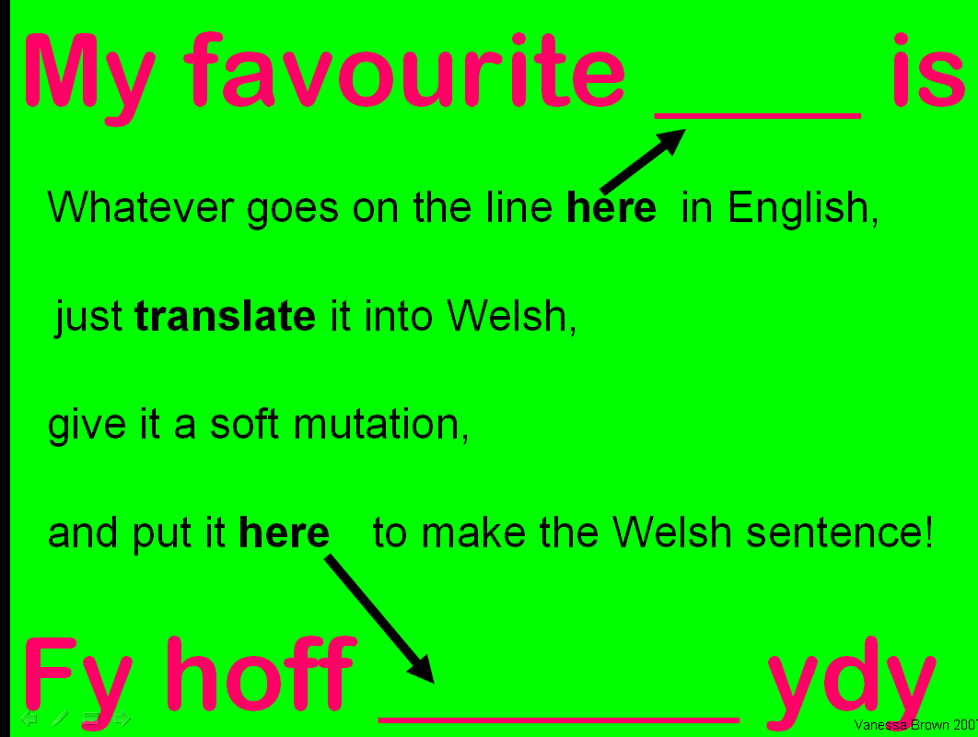 | - These slides demonstrate how to structure the sentences ‘Fy hoff ___ ydy’ and ‘fy nghas ____ ydy’.  - Slide 2 aims to encourage pupils to think for themselves.
Slide 4  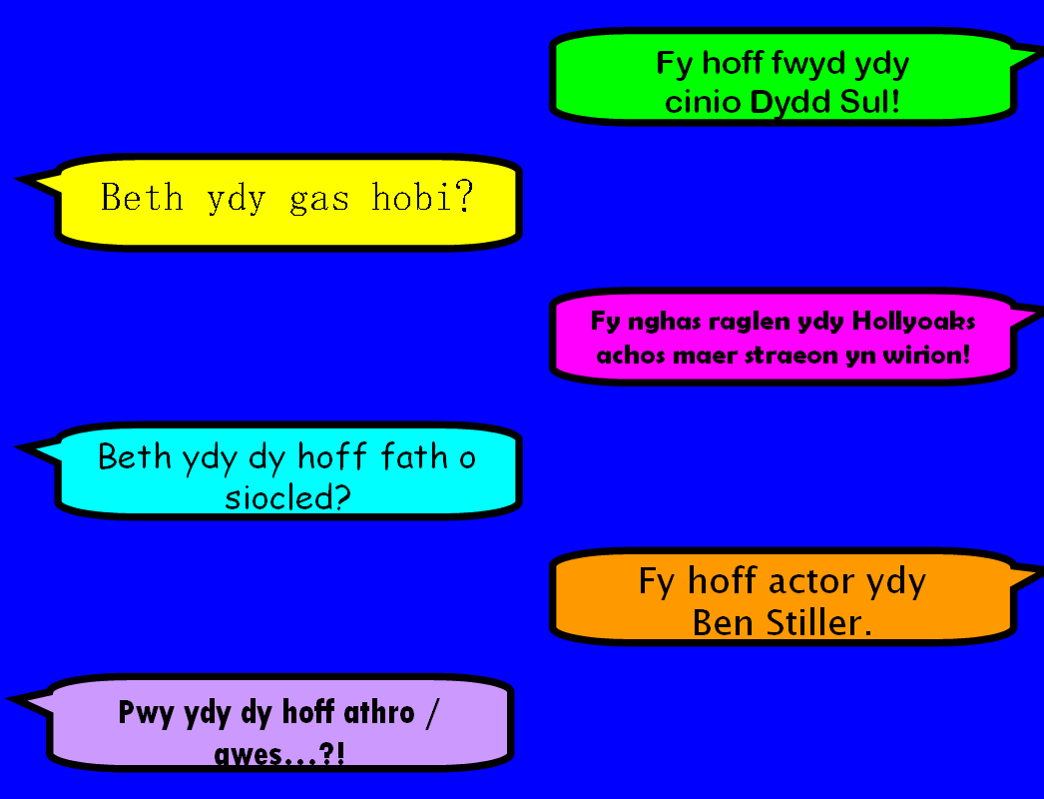 | - Click to reveal some questions and answers.  - Ask pupils to think of a question that would correspond with the answer and vice versa. Click again to reveal ? and a time limit.  - Clicking the ? will give the correct question or answer. | Mini whiteboards.  Point out that when talking about a person ‘beth’ must be changd to ‘pwy’ and that other questions may be used, the structure remains the same.
Slide 5 | - Encourage pupils to give their answer.
Slide 6  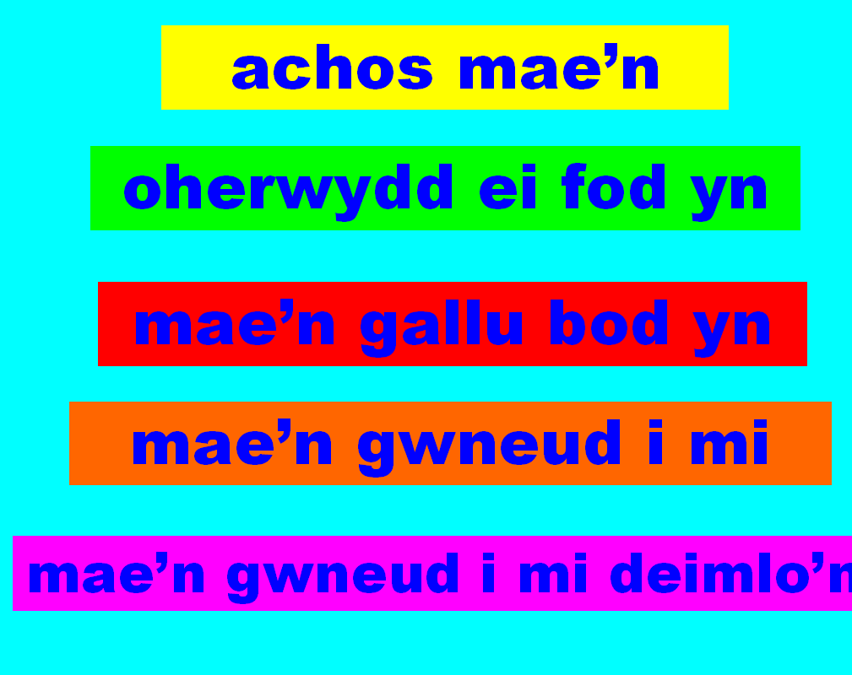 | - Refer back to work done previously in the ‘Pam’ section and point out that the same phrases may be used here.  - Using the marking schemes that appear, point out that giving reasons to support opinion is important.  - Ask pupils to answer the question on slide 5 once again, now using one or more of these phrases to improve their answer and to give a valid reason.
Slide 7  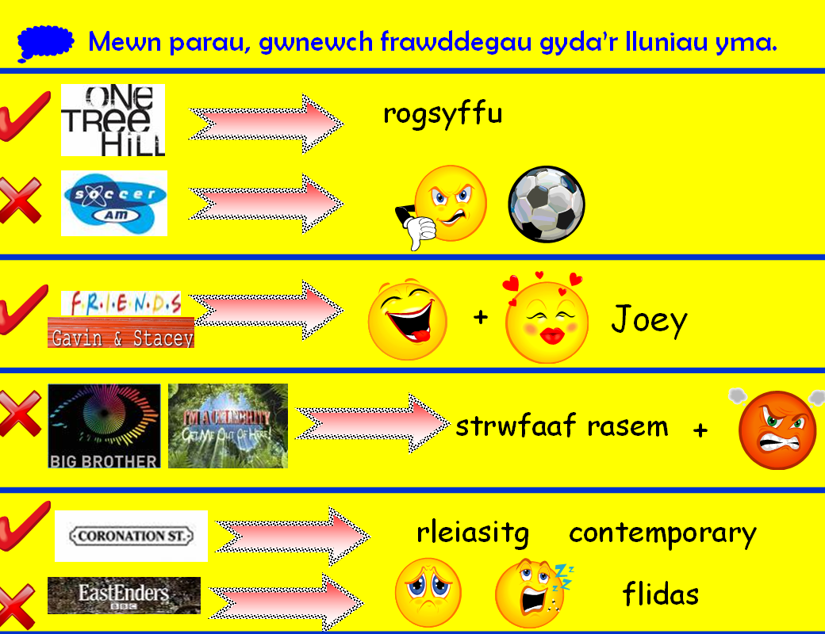 | 1. Pupils to create full sentences using the prompts. An example is given upon clicking. | May be done in pairs or as a class.  If done in pairs, most able pupils should have a conversation using one or more of the prompts.  Extension: Ask pupils to write their sentences fully.
Slide 8  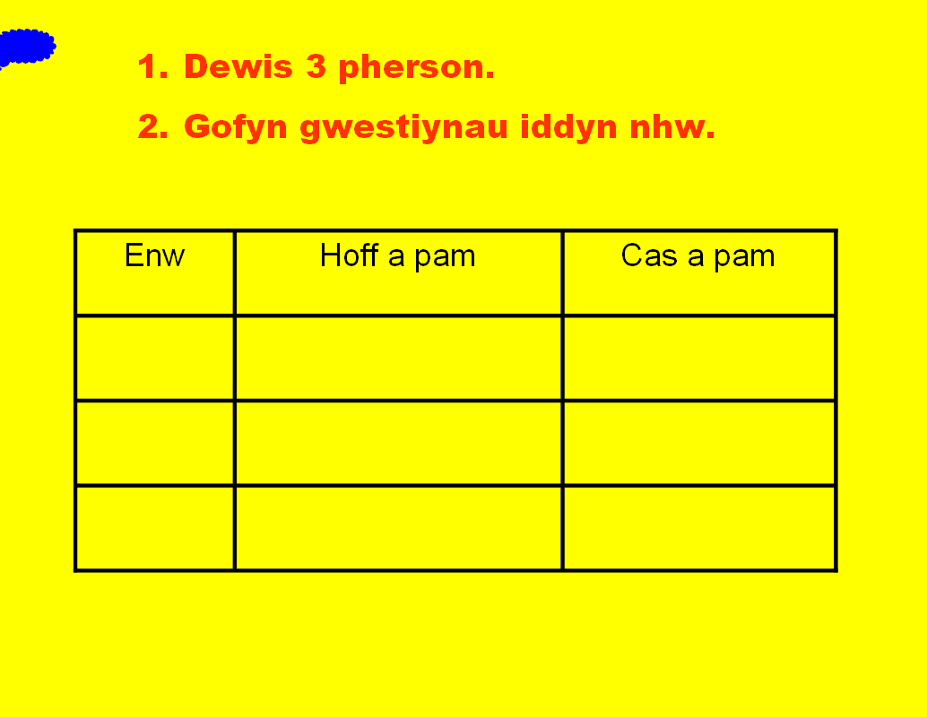 | - Hand out worksheet 2. Hoff-Cas Raglenni.  - Pupils to survey their classmates about their favourite and least favourite television programmes.  - An example is shown.
Word Document  2. Hoff-Cas Raglenni  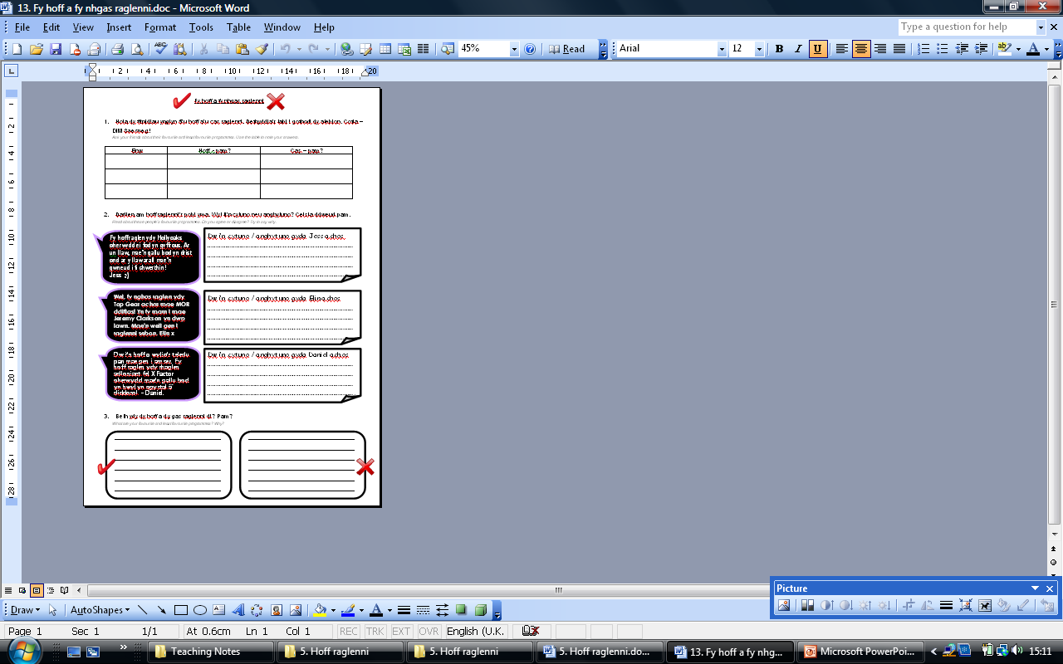 | - Task 1 corresponds to above slide 8.  - Task 2 – reading.  - Task 3 – writing. | Tasks 2 and 3 are prompted in slides 11 and 12 of PowerPoint.
Slide 9 | - Explain how to change from the 1st person to the 3rd person.
Slide 10  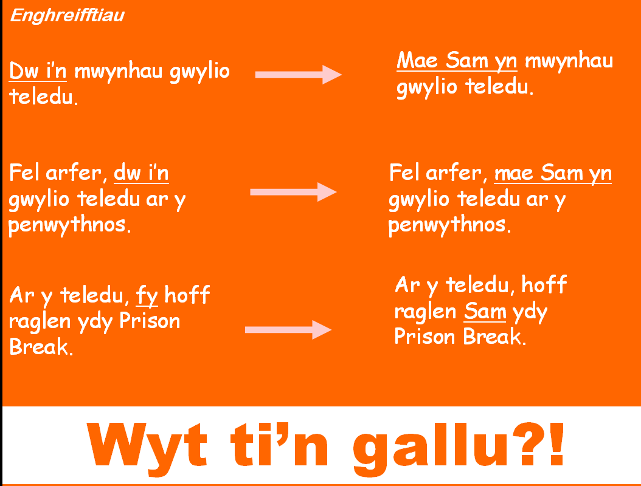 | - Show examples of how to change from 1st to 3rd person.  - Three sentences are given in 1st person, pupils to work in pairs to change to 3rd person.  - Set homework to write in the 3rd person about heir survey findings. | Mini whiteboards.  Point out hat it is not only ‘dw i’n’ that changes but also ‘fy’ and ‘i’.
Slide 13 | - Encourage pupils to answer the questions once again.  - Their answer should have improved from slide 5. | Peer assessment opportunity.
Slide 14 | - Set this homework in order to improve answers further.
Word Document  3. Darllen a Deall  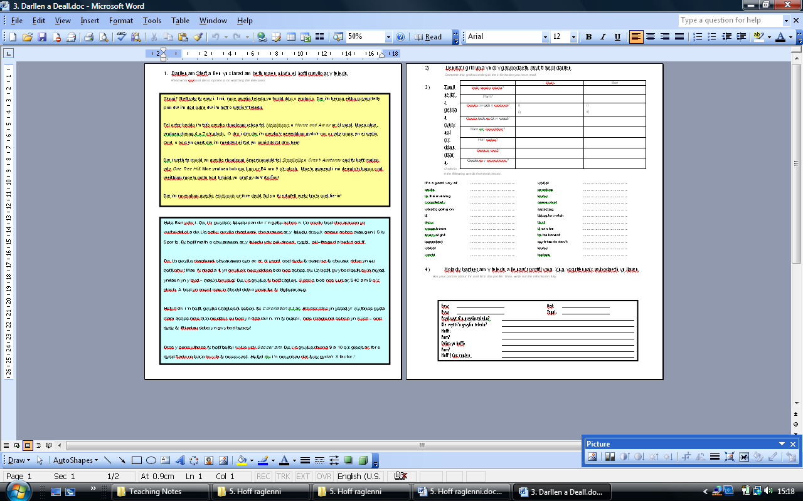 | - Give as possible homework or extension work.
Power Point  4. Sky+  Slides 1-4 | - Miss Brown’s planner may be used as a template and changed.  - Clicking on the programmes ‘Dora the Explorer’, ‘Prison Break’, and ‘Friends’ will take you to an explanation as to why they have been chosen. ‘Back up’ will take you back to the first Sky+ screen.  - Ask individual pupils to read aloud, or to do so in pairs, trying to understand new words and phrases in the text.  - Word document 5. Fy Hoff Raglenni Sky+ includes further information about the Sky+ planner together with comprehension questions. Not all the information needed to answer the questions is in this document, some is in the PowerPoint itself, therefore, when going through slides 1-4 as a class, pupils must make notes in order to answer the questions.
Slide 5 | - Read further information with pupils and hand out copies of Word document 5. Fy Hoff Raglenni Sky+.
Word Document  - Fy Hoff Raglenni Sky+  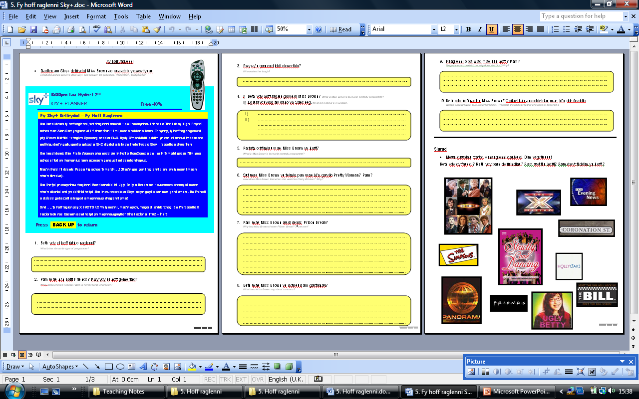 | - Pupils to complete the questions based on the text (copied from slide 5) and the information read in slides 1-4.  - Speaking task: Pupils to work in groups of 4 to discuss their opinions about the television programmes in the pictures.
Word Document  - Fy Sky+  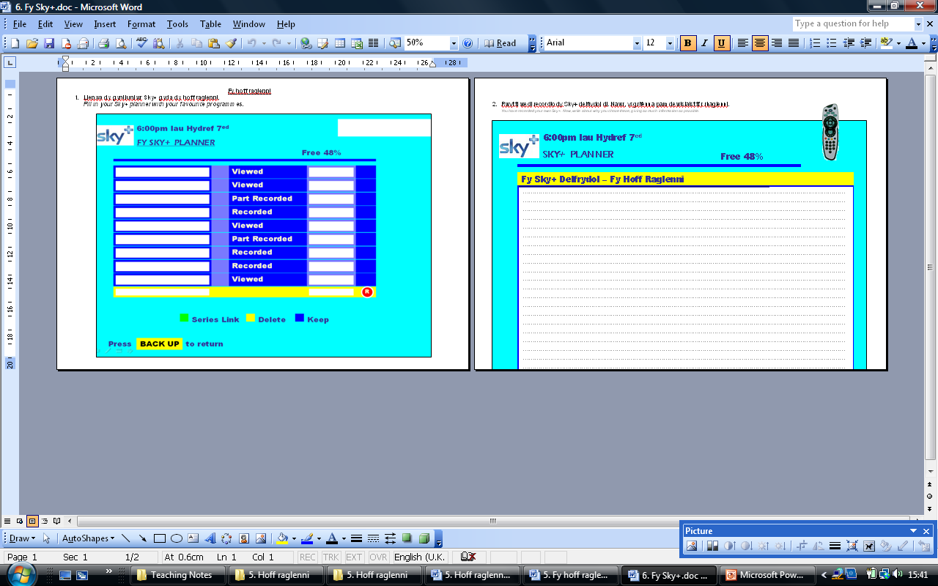 | - Print document back to back.  - Pupils to fill in their own Sky+ planner with their favourite television programmes.  - Pupils to then write about those programmes in the space provided.  - Pupils may use the text in the reading comprehension 5. Fy Hoff Raglenni Sky+ for support.

